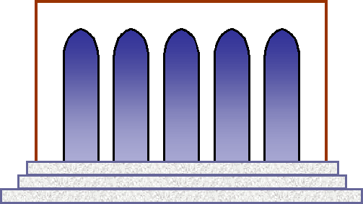Cowles Library

#### Interview Release Form

# Project name:_________________________________________

### Date:_______________________________

Interviewer:__________________________

Tape number:_________________________

Name of person(s) interviewed:_____________________________

Address:____________________________

Telephone number:_____________________

## Date of birth:__________________________

By signing the form below, you give your permission for any tapes and/or photographs made during this project to be used by researchers and the public for educational purposes including publications, exhibitions, World Wide Web, and presentations. By giving your permission, you do not give up any copyright or performance rights that you may hold.

I agree to the use of the materials described above, except for any restrictions, noted below.

Name (please print):_______________________________________

Signature:______________________________________

Date:_________________________________________

Researcher’s signature:_____________________________

Date:__________________________________________

Restriction description:______________________________________